How will you get your certificate?

* Pick up
* Mail

Payment can be made on the website at <https://www.angermanagementoftheupstate.com/>

**PLEASE PRINT**

Date: ________________________________

**Please write you name as it will appear on the certificate**:

Name: ______________________________________________________________________________

Address: _____________________________________________________________________________

Phone: ______________________________________________________________________________

Email: _______________________________________________________________________________

**Replacement certificate are $5 plus an additional $5 for shipping and handling if mailed.**

Thank you for your business!

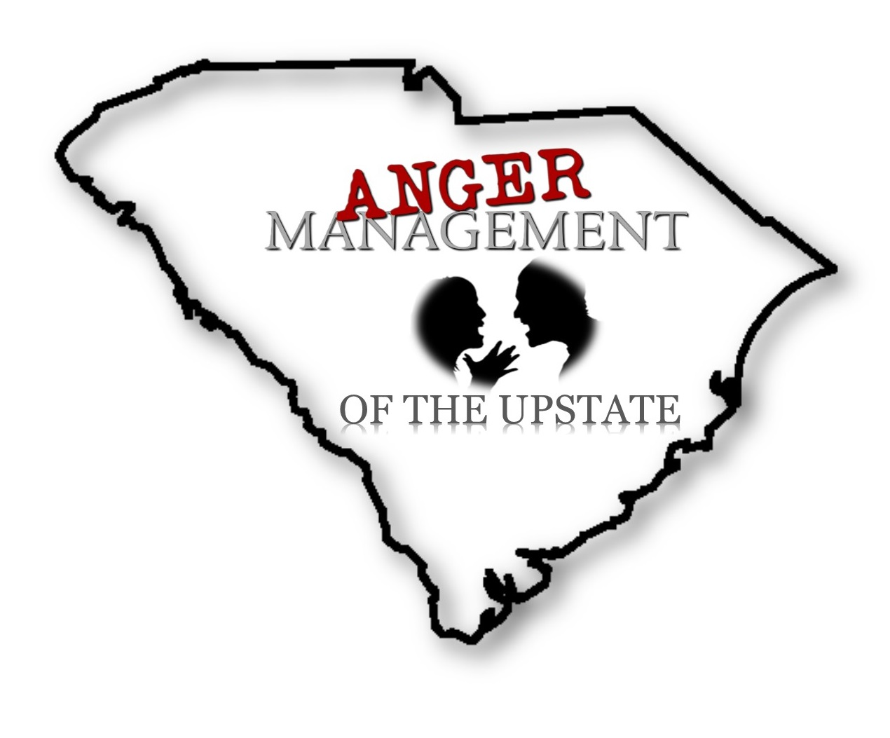

**Anger Management of the Upstate**

***Certificate Request Form***